End User Manual for Patient Parameter Monitor

1 Getting started with iCARDEA Patient Parameter Monitor (PPM) 1
1.1 Starting the PPM 1
1.2 The Top „General Information“ 4
2 The bottom „PPM Main“ and its views 6
2.1 The View “Overview” 7
2.2 The View “VT /VF” 8
2.3 The “PatInfo” View 9
2.4 The ProPara – Programmed Parameter View 12
3 General Information about missing data 13
4 General solutions if something went wrong 14

Getting started with iCARDEA Patient Parameter Monitor (PPM)
The patient parameter monitor is developed to show collected patient data at a single point
PPM is a visualization tool which runs in a web browser. Therefore you need the correct URL of PPM or use the link provided by the central iCARDEA website:
https://icardea-server.lksdom21.lks.local:8443/ppm_v2/view?startup=de.offis.health.icardea.ppm.viewapp

Starting the PPM
When you start the PPM-Website, you have to log in with your SALK username.
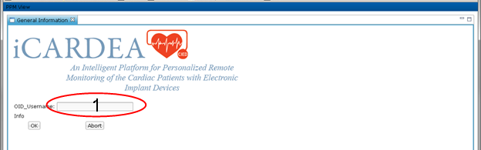
Figure 1 Logging Screen

If you are not allowed or your username is not known by the iCARDEA system you will get the following error message. In this case please read section 4 or contact the administrator of the iCARDEA system
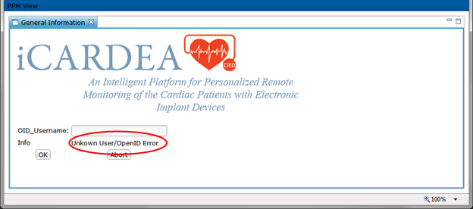
Figure 2 Error message in Login Screen
If you are using the system the first time, you might be redirected to the openID identity page. There you have to enter your password.
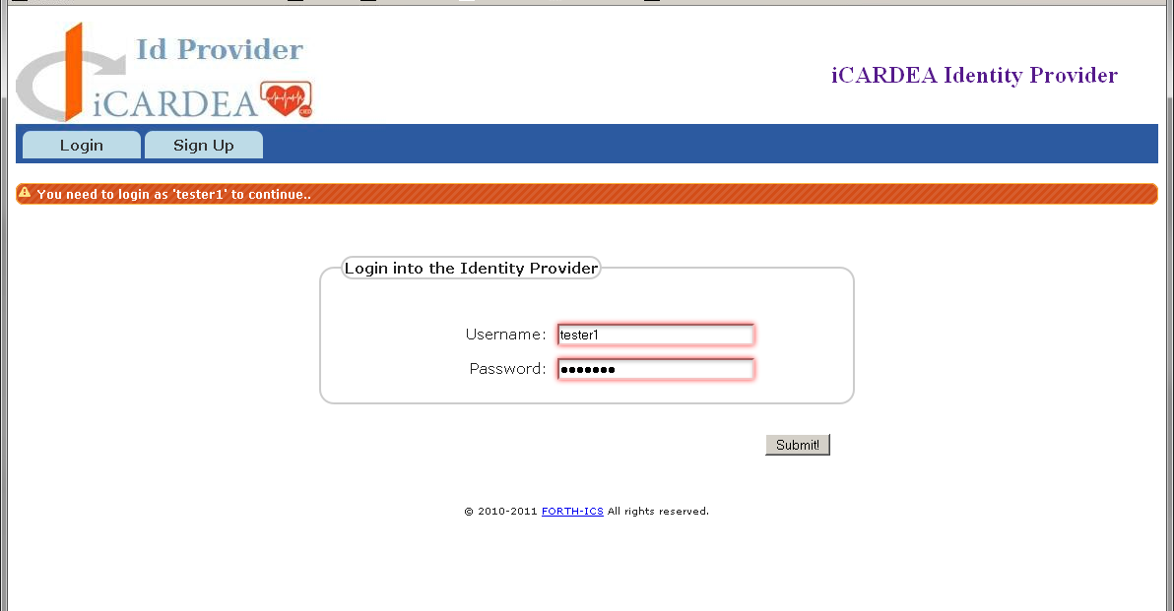
Figure 3 Logging Screen of the identity provider

There please enter your credentials and log in into the system. In the next step you have to approve the PPM website. To do this you have to check the "Remember this decision" checkbox and press the yes button.
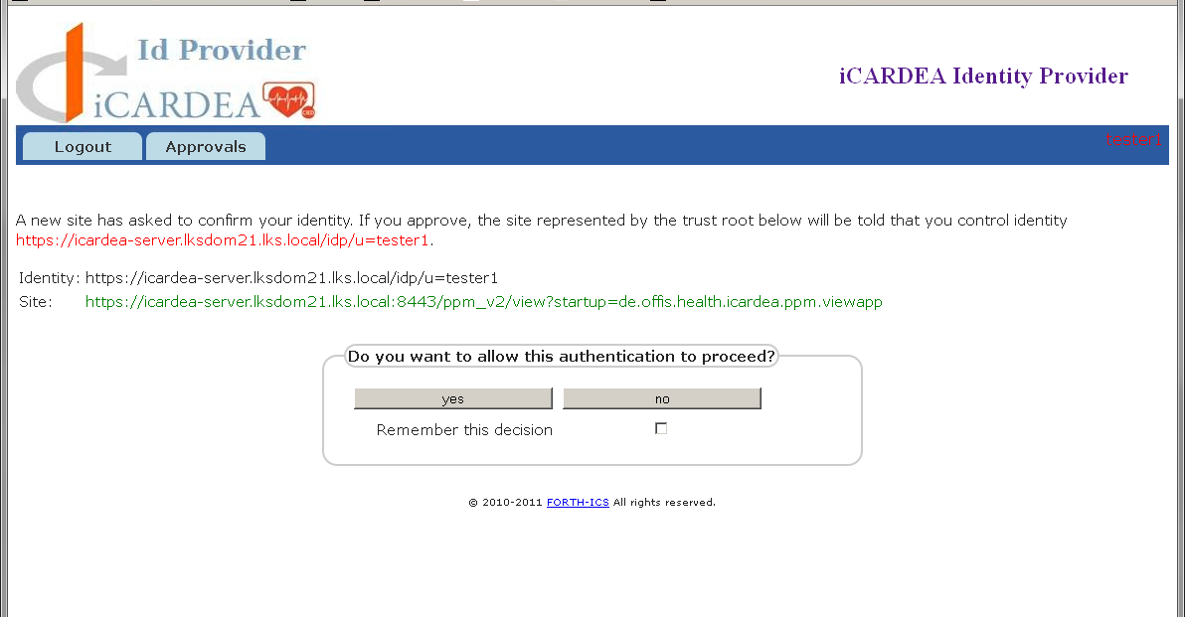
Figure 4 Approval screen of the identity provider

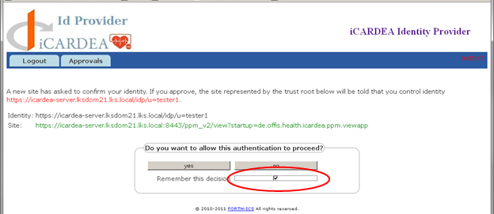
Figure 5 Approval screen of the identity provider, checkbox for remembering the decision
If you were already signed in and approval for PPM was given, you will be redirected to a webpage where you see a drop down list of patients.
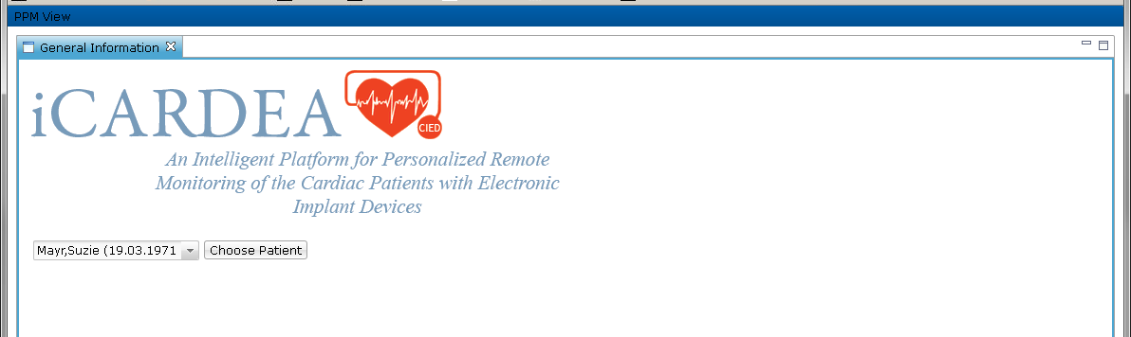
Figure 6 Patient Chooser screen

The list of patients depends on your role at the clinic and the security settings at the consent editor. If you don’t find a specific iCARDEA Patient, please make sure that you are allowed to access the patient data.

The Top „General Information“
After your successful login you see the following screen
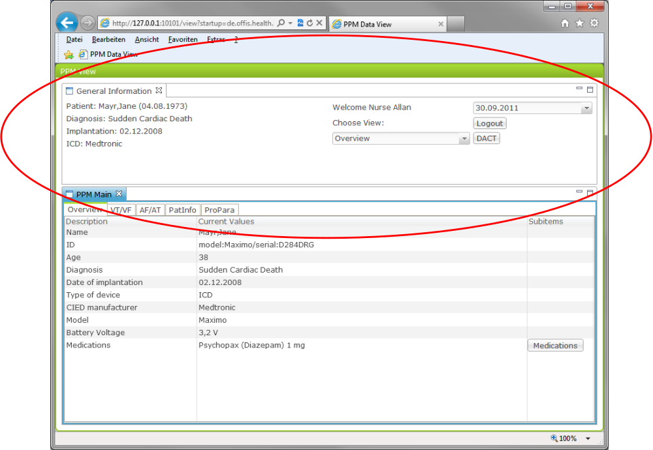
Figure 7 The General Information Window
On the General Information Window you can see following details:
Patient: The Name and, if available, the birth date of the chosen patient
Diagnosis: The major diagnosis of the patient as stored at the iCARDEA caremanagementDB
Implantation: The date, when an ICD or CIED device was implanted
ICD: The vendor of the implant
At the Welcome notice you can see your security rank (Nurse, doctor) and your name
The dropdown list „choose view“ offers you different predefined views for showing different groups of patient parameters.
Beyond there are two buttons:
The DACT button shows you the Data Analysis and Correlation Tool with pattern suggestions for the current selected patient
The Logout button logs you off and will prevent the further usage of your account at the system.
You can minimize or maximize the „General Information“ easily by double click the line between the „General Information“ and „PPM Main“ Window.

The bottom „PPM Main“ and its views
For PPM different views were predefined which are shown at the PPM Main window. The views consist of data items of a patient that are grouped into topics called for e.g. „Overview“ „VT/VF“ „AT/AF“ „PatInfo“ „ProPara“.
The definition of the views and the item sets where done by medical professionals from SALK and HCPB.

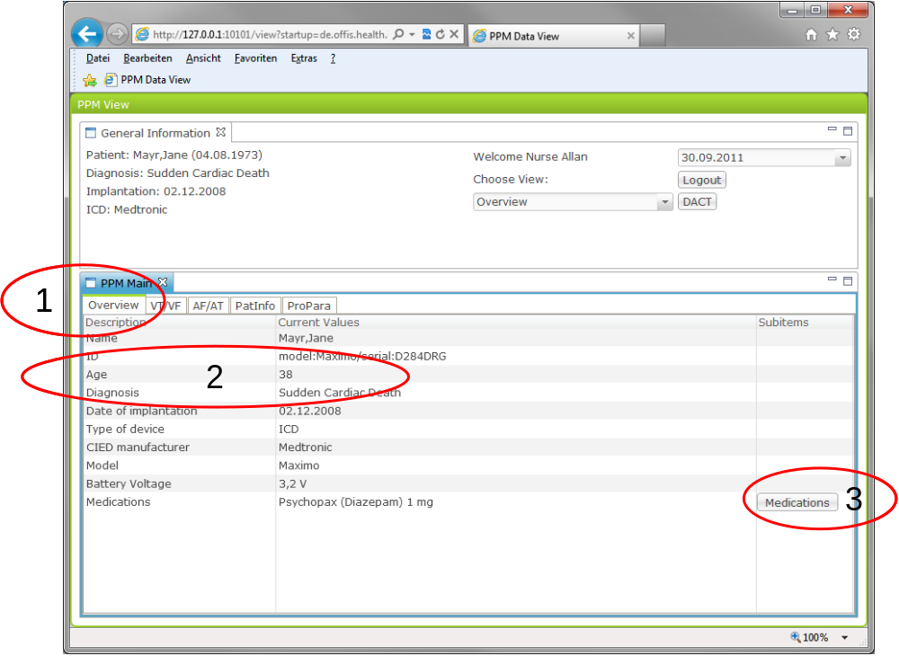
Figure 8 The Structure of PPM Main Windows

The views are always presented in a sheet view as tabs. The columns of each view consist of different topics which are defined in the first row. At the shown example, the view “Overview” (see mark 1) is chosen. It has the columns “Description”, meaning the description of the specific data item, the column “Current Value”, meaning the latest value stored at the iCARDEA caremangementDB (e.g. at the mark 2: The current viewed patient Jane Mayr has a age of 38 ). At multiple views there are also SubItems available, like the Medications (marked 3). These are selectable and are indicating that to the specific topic of the description (Medications) there is another, normally more extensive view available.
Remark: Since the Views are dynamically generated and can easily be adapted to new requirements, the following presentation of view can differ in specific items. Please have a look at your local installation, what itemsets are currently available.

The View “Overview”
This is always the first presented view. It is intended to give the user an overview over all the major patient data. If all Current Values can be set depends on the availability of the datasets to the iCARDEA environment.
If the Genalview is not needed, you can maximize these using the window resize button (red circle):
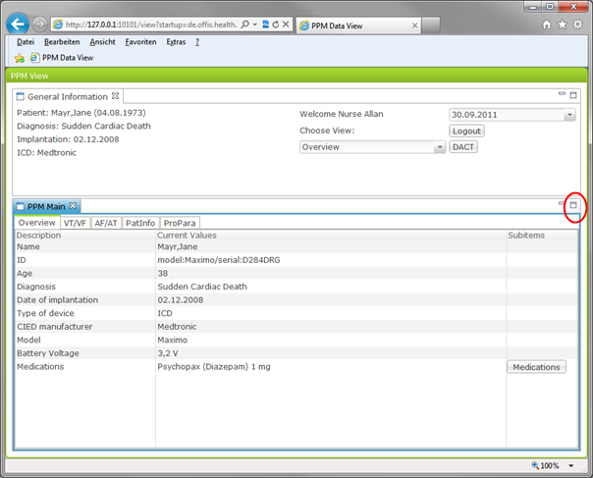
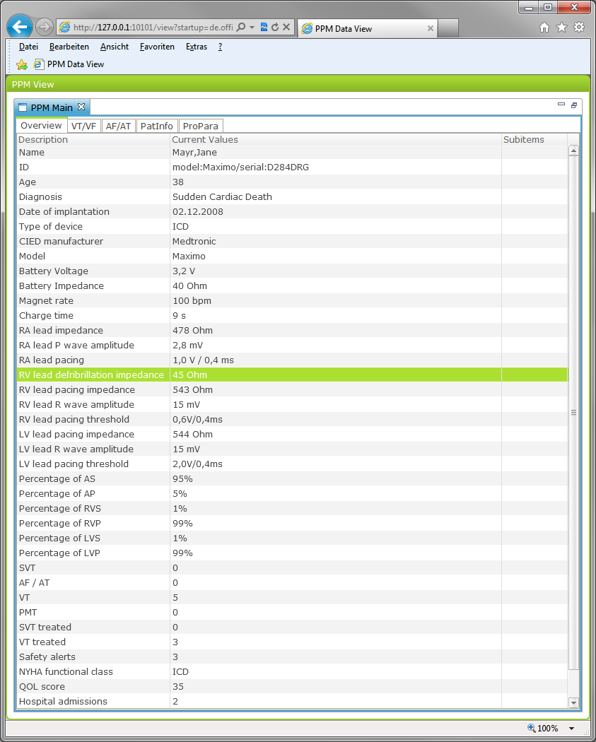
Figure 9 Overview Sheet in Full Screen mode

The View “VT /VF”
Here you see the defined main parameters for the VT / VF view of a patient, holding items like VT zone and information about episodes. Please notice the red marked line about “Medication compliance”.
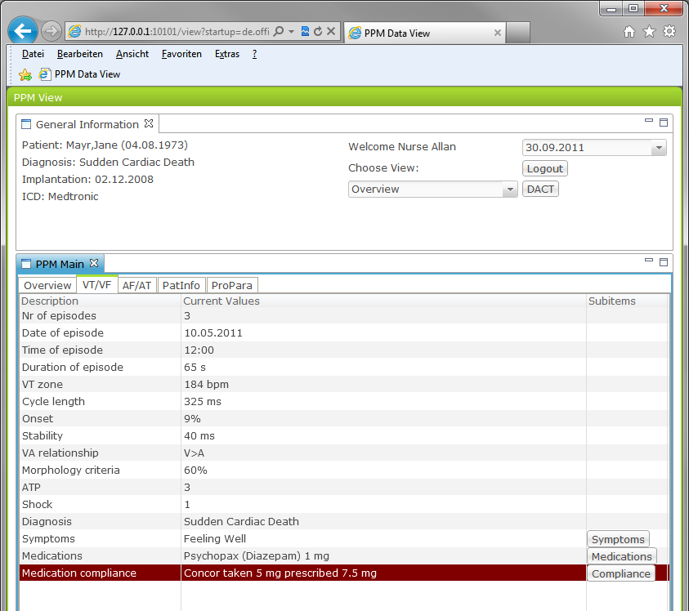
Figure 10 VT / VF Information View
Red marked lines indicates special findings or derivations from predefined consistency rules. In the shown view, it is possible to click onto the Compliace Subitem to gather additional information.

The “PatInfo” View
PatInfo refers to the patient information view. Here all data about the Patient is shown, which is usually important for ICD / CIED patients.
In this case the shown symptoms are gathered from the PHR System, witch was connected to the underlying iCARDEA environment. Also the sub item view medication contains information gathered from your local Hospital system or an external Personal Healthcare Record System.
Note: Since we realized that it is important for healthcare actors to know from where the data origins, the Views where updated and now indicate if they origin from the hospital (EHR) or are external information provided by the patient himself (PHR)
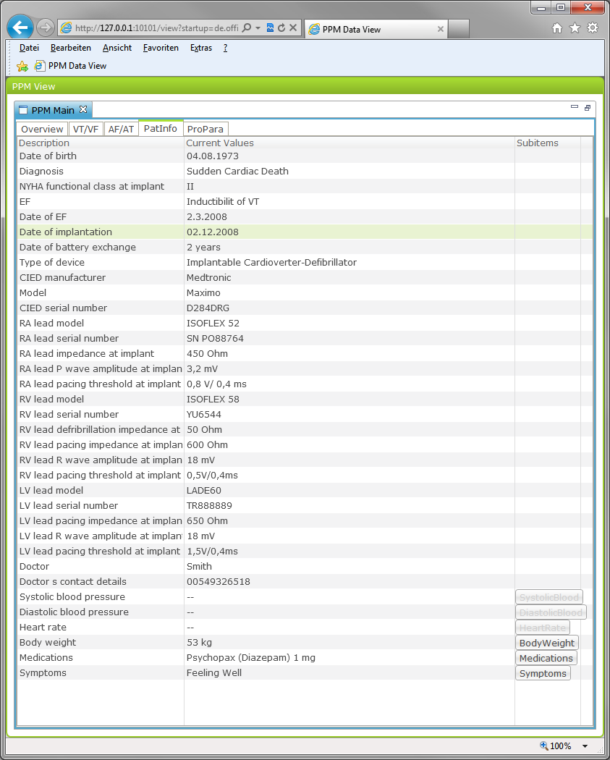
Figure 11 The PatInfo - Patient Information View
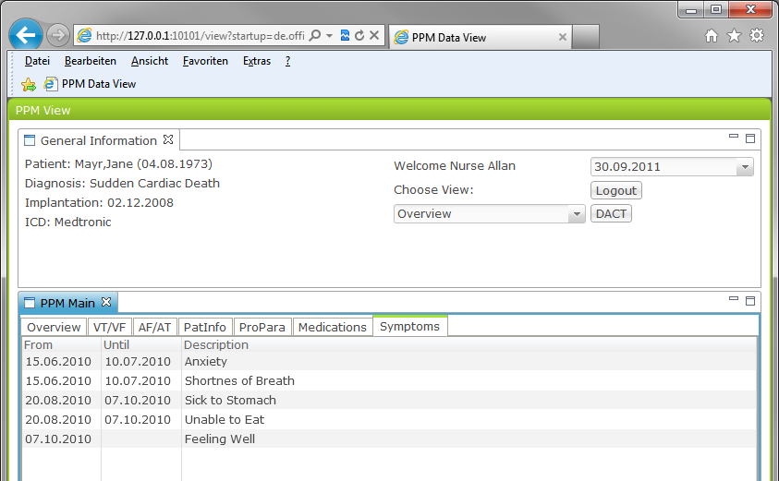
Figure 12 The Symptoms Sub Item View

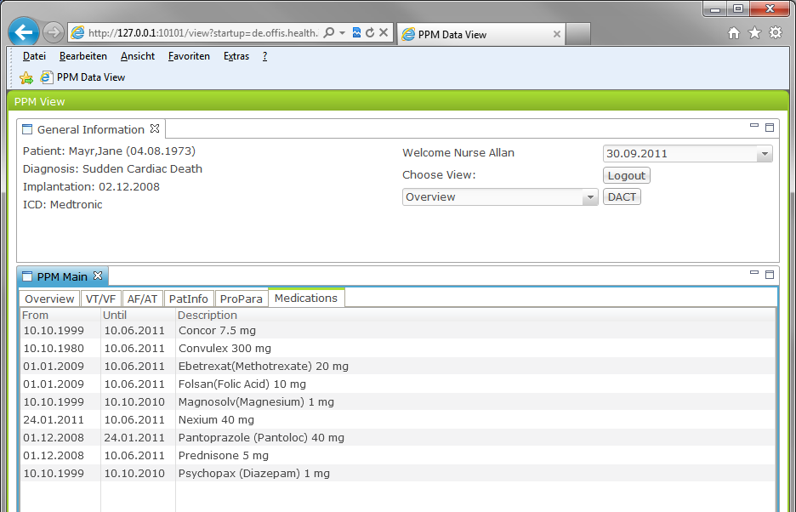
Figure 13 The Medications Sub Item View

The ProPara – Programmed Parameter View
At this view parameters read from the CIED reports are presented. Since the electronically available data items at the CIED Reports varies from ICD/CIED vendor to vendor and also from report to report it is high likely that there will be empty data sets.

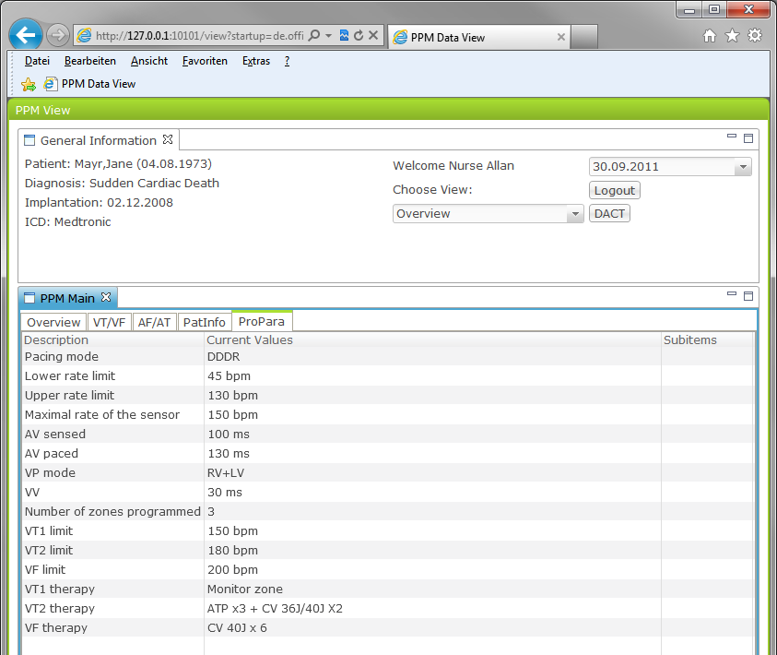
Figure 14 The ProPara - Programmed Parameter View

General Information about missing data
Since the Patient Parameter Monitor aims to display data items for a patient from a variety of different sources (different CIED vendor systems, clinical information systems, PHR systems) it highly depends on the underlying clinical infrastructure, which data is shown.
Also the patient itself will not have all data available: If a patient doesn’t use the PHR System or doesn’t allow that healthcare actors can look at it, the data will not to be shown due to the security and privacy regulations and systems.
If you in general miss a parameter or want a special view, you can contact the iCARDEA team. Due to the generic solution it is easily possible to change or add views. If the data item is available from the iCARDEA system will then be clarified.

General solutions if something went wrong
Since PPM is a Web application for evaluation purposes it can sometimes show unexpected behavior. Some general solutions
Login says “Unknown User / OpenID Error”:
- Just try a second time.
- If that doesn’t work, please call the OpenID page itself and try, if your user ID is still valid
- Otherwise: Ask iCARDEA-IT-Support and mention, that maybe OPENID isn’t running
PPM doesn’t start:
- If an error message appears fast, that the side could not be found:
  - Check, if you have the correct URL.
- Otherwise: Ask iCARDEA-IT-Support and mention, that maybe TOMCAR isn’t running
PPM shows a message: Can’t create initial views
- Directly call iCARDEA-IT Support and mention, that MYSQL isn’t running
PPM doesn’t show the Top View so you can’t logout
- Double Click on PPM Main or on the top line above PPM Main.
- Try to click and move the top line above PPM Main down to see the Logout Screen Sometimes the “General Information “ is hidden automatically to provide more space for patient data.

In general: You can always close the PPM Webpage without damaging data or the application. You should always use the Logout to prevent the re usage of your account.

